

|  |
| --- |
| **Documentation VideoWorld** |
| Web Engineering |
| Version: V1.0, 23.12.2013   |  |  |  | | --- | --- | --- | | **Authors** | Sadik Pepic | [pepicsad@students.zhaw.ch](mailto:moserfa1@students.zhaw.ch) | |  | Srdjan Peric | [pericsrd@students.zhaw.ch](mailto:pericsrd@students.zhaw.ch) | |  | Tim Schubiger | [schubtim@students.zhaw.ch](mailto:moserfa1@students.zhaw.ch) | |  | Reto Vestner | [vestnret@students.zhaw.ch](mailto:moserfa1@students.zhaw.ch) | | **Department** | ZHAW – School of Management and Law | | | **Class** | WIN12HSVZb | | | **Module** | Software Engineering | | | **Semester** | HS2013/2014 | | | **Committed on** | Friday, January 10 2014 | | |

**Table of contents**

1 Document purpose 3

2 Project’s motivational drivers 3

3 Project Use for future users 4

3.1 Main page 4

3.2 Movie page 9

3.3 TV show page 10

3.4 Registration page 10

3.5 Search results page 12

3.6 Subscription page 13

3.7 Watching Video page 15

3.8 Actors page 18

3.9 Errors, messages and validations 19

3.10 Screen size adaption / mobile usability 20

4 Technical requirements and guide for the installation 23

4.1 Information 23

4.2 Technical requirements 23

4.3 Installation guide 23

5 Technical Implementation 24

5.1 Architecture 24

5.2 Entity Relationship Model (Database) 24

5.3 Technologies used 25

6 Meeting and exceeding requirements of Web Engineering Module 26

6.1 Technological requirements 26

6.2 Content requirements 27

6.3 Additional requirements 28

# Document purpose

This document’s purpose is to describe

* Project’s motivational drivers
* Project use for future users
* Technical requirements and guide for the installation
* Technical Implementation
* Meeting and exceeding requirements of Web Engineering Module

# Project’s motivational drivers

The purpose of this project was to develop an online platform named **VideoWorld**. It fulfills the need of internet users who wish to watch movies and TV shows online. Although there are already many existing video platforms, VideoWorld will be able to stand out from the crowd by delivering the same amount of movies/TV shows as other famous platforms (e.g. iTunes, SwisscomTV) whilst not requiring purchasing or lending every video. Instead VideoWorld aims at enthusiastic customers, willing to pay for a subscription (daily / monthly / annually). This enables them to watch as many videos as they wish on our website during the chosen period that was paid for. The overall target of the project is to be customer-driven at all times and thus binding customers in the long-term.

Before initiating this project, the sponsor consulted external experts from a web consulting firm who confirmed, that the potential Return-On-Investment of such a project is estimated to be enormous. Also, several recent projects of ours were successful in terms of customer satisfaction. They all were implemented with the application of similar subscription schemes. This concluded the decision to start this project and constitutionalized its purpose financially and businesswise.

# Project Use for future users

This chapter coherently describes all the functionality that is useful for future users of VideoWorld.

## Main page

This is the index page of the project:

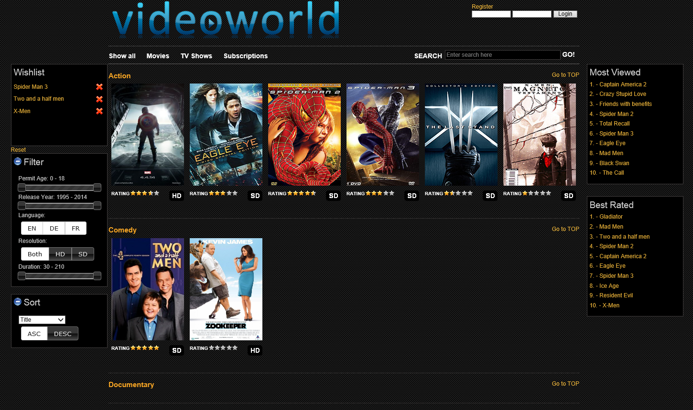

The main page of VideoWorld shows the user the following features:

* Overview of movies **and** TV shows grouped by genres

(Movies have a rating from 0.5 – 5.0 stars and an attribute whether they are HD (High Definition) or SD (Standard Definition). Also all movies/TV shows are draggable 🡪 see *Wishlist*).

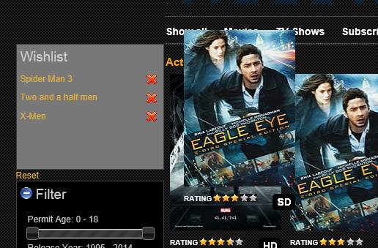

These movies / TV show the User its name and a semi-transparent “play-image” by hovering over it, if interested by the movie cover. Clicking on a movie / TV show leads to the player (If logged in and paid for a subscription):

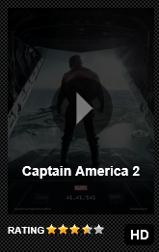

* Wishlist

In this section the user can drop a dragged movie / TV show he or she wishes to watch at a later time. This list is limited to 5 elements of which each can separately be deleted by clicking on the cross next to it or all at once by clicking the ‘Reset’-Button below the list. Clicking on a movie / TV show leads to the player (If logged in and paid for a subscription):

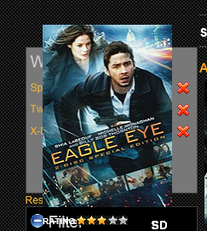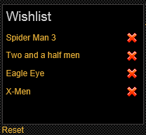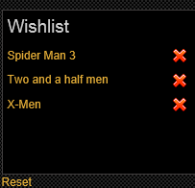

* Filter section

This section is dynamically set to provide filters based on the minimum and maximum values retrieved from the database (Example: The movie with the lowest permit age, 0, sets the filter to this exact number). The filter section provides the user with a mighty tool to quickly filter movies that are not appropriate for him/her:

* + The range of the permit age of the movies / TV shows
  + The range of the release year
  + Buttons for the languages wanted (currently only English EN, German DE and French FR). Multiple, all or none can be chosen.
  + Buttons for the resolution wanted (currently only High Definition HD and Standard Definition SD). HD **and** SD, only HD or only SD can be chosen.
  + The range of the duration of the movies / TV shows

The entire filter section can be hidden by clicking the + / - next to its title.

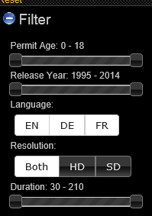

Before Filtering:

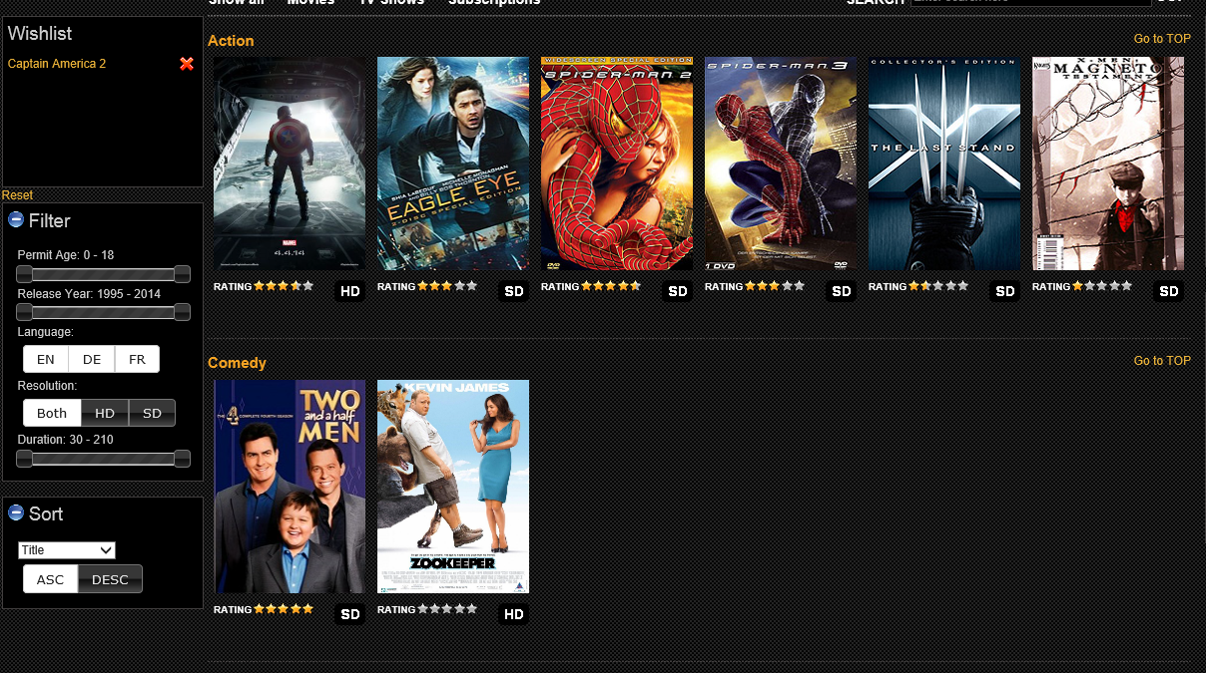

After Filtering (Permit Age between 14 and 18):

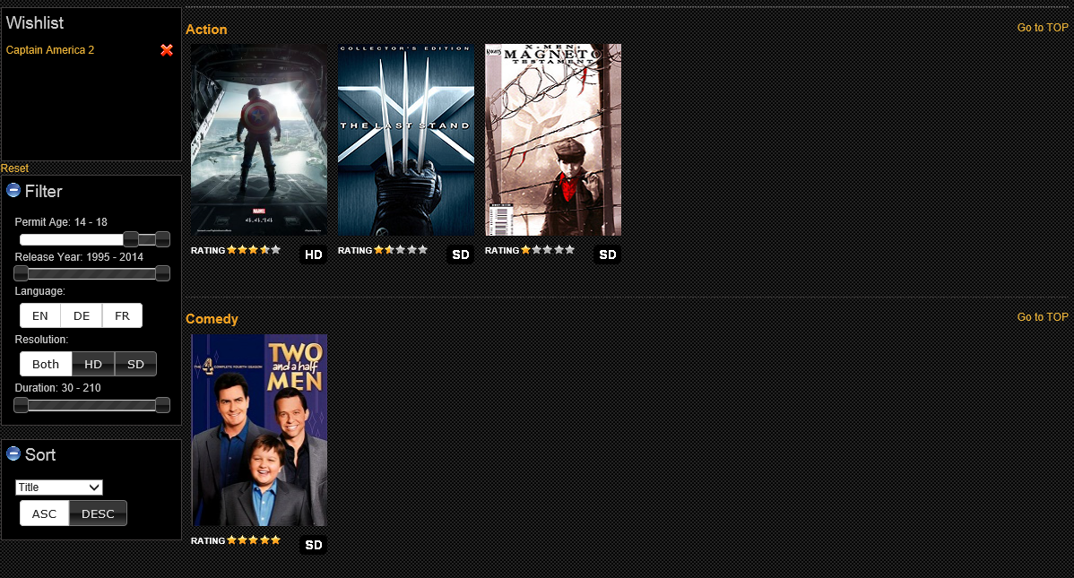

* Sort section

This section provides the user with a tool to dynamically sort the movies within a genre by a specific attribute (e.g. Title) and whether it should be an ascending or descending order. The entire sort section can be hidden by clicking the + / - next to its title.

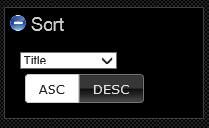

Before sorting (Standard by title ascending):

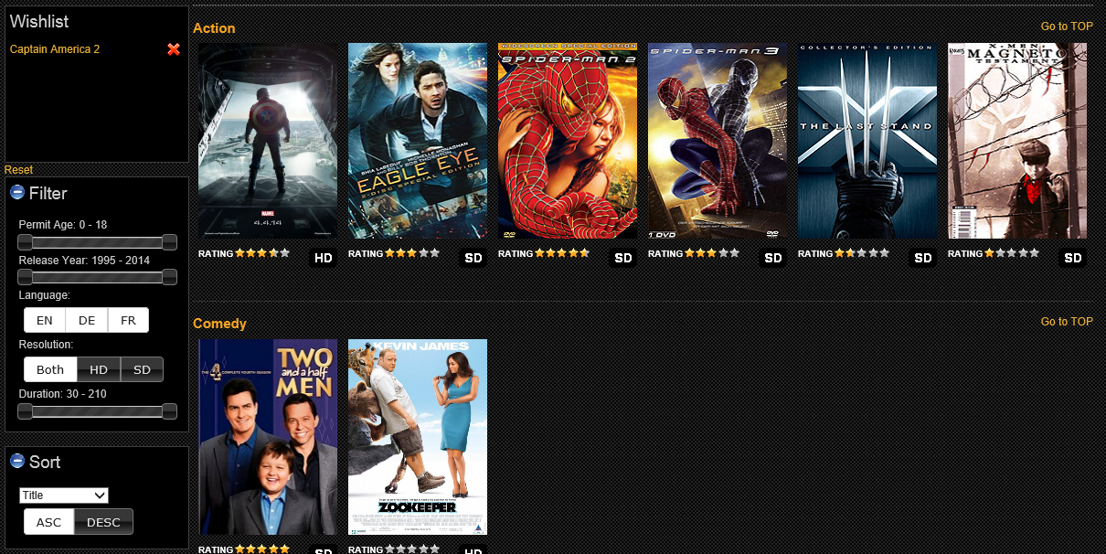

After sorting (Permit age descending):

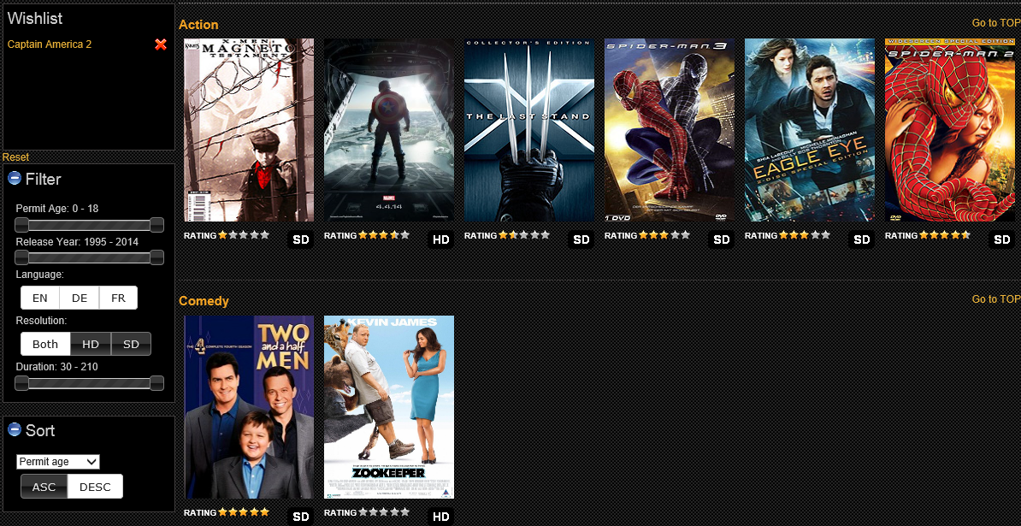

* Most Viewed

This is a sorted TOP 10 list of all the movies / TV shows which were viewed the most. Clicking on a movie / TV show leads to the player (If logged in and paid for a subscription).

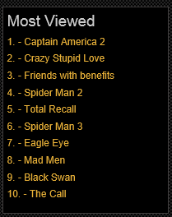

* Best Rated

This is a sorted TOP 10 list of all the movies / TV shows which were rated the best (by average). Clicking on a movie / TV show leads to the player (If logged in and paid for a subscription).

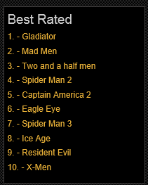

* Sidebars

All the sidebars follow the users’ scrolling, enabling him not to have to scroll up every time he wants to see them.

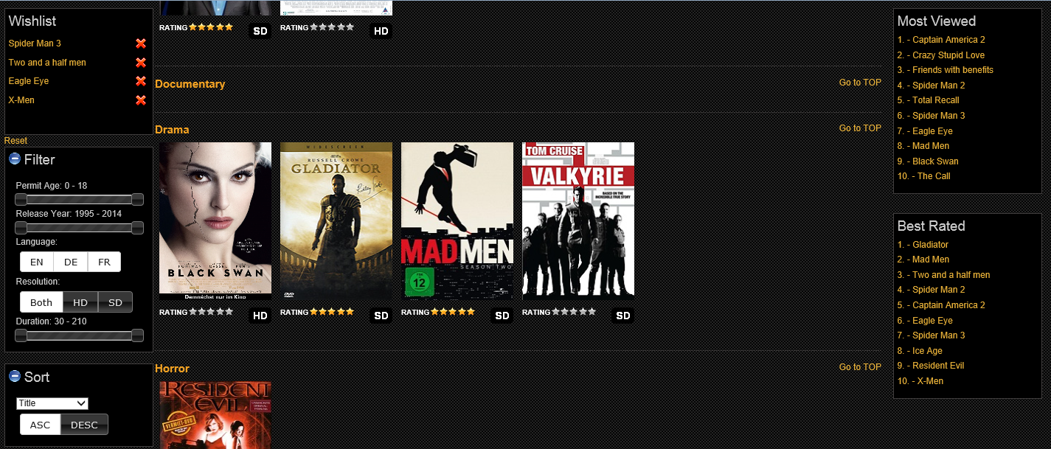

* Searchbar

VideoWorld has a dynamic search which shows results as the user types in his search words.

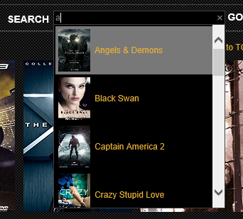

If the user clicks on GO or presses ENTER he is forwarded to a separate search result page.

* Login

The page has a login consisting of username and password. After login, the user is presented with an overview whether a valid subscription is still available or not:



Logged off Logged in, valid subscription Logged in, no valid subscription

## Movie page

By clicking on movies in the header the user is redirected to the movie page. This page is exactly the same as the Main page, except that it only shows movies. Filters/sortings and TOP 10 lists apply only to movies.

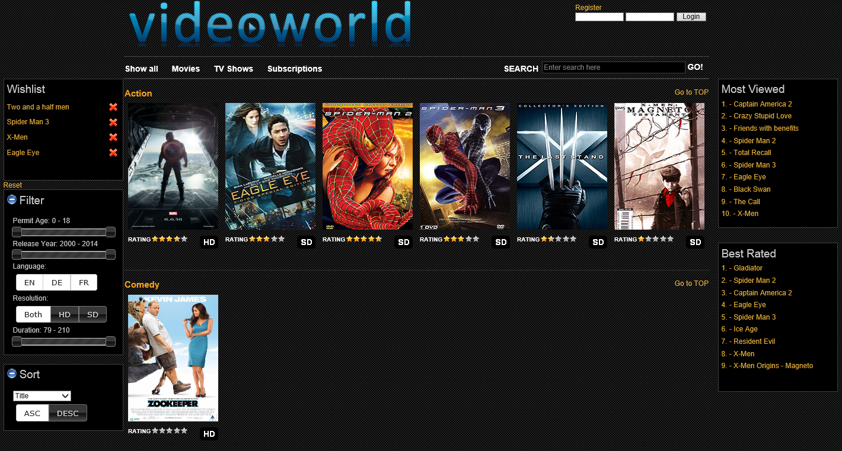

## TV show page

By clicking on TV shows in the header the user is redirected to the TV show page. This page is exactly the same as the Main page, except that it only shows TV shows. Filters/sortings and TOP 10 lists apply only to TV shows.

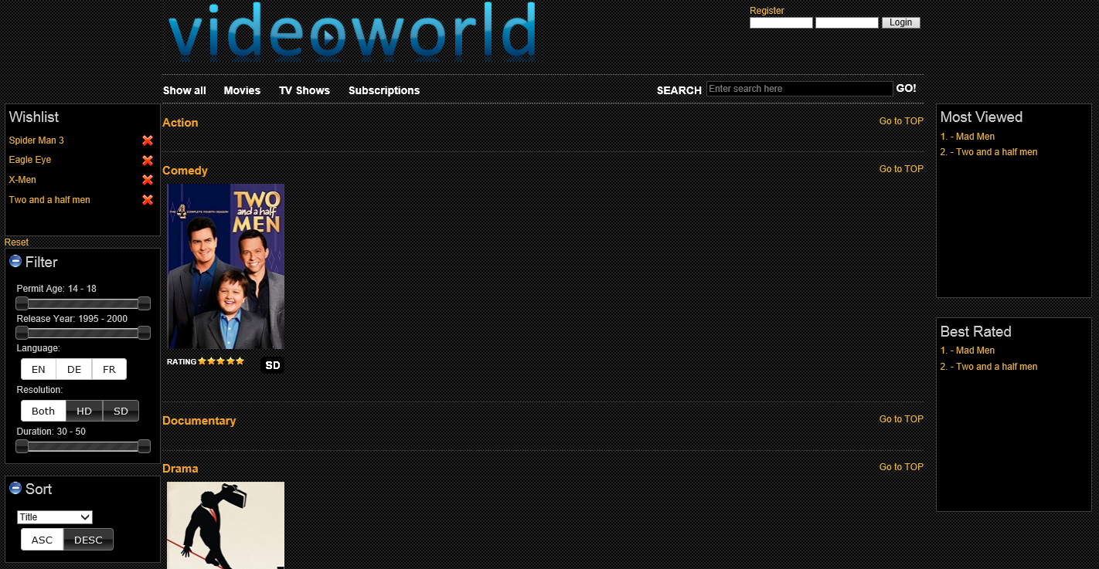

## Registration page

Users who want to register, can do so on the registration page.

The following information is mandatory:

* Last Name
* First Name
* Birthdate
* E-Mail (must have correct format 🡪 checked by page)
* Username (must not already be taken by someone else)
* Password (Must have at least 8 characters, stored as md5-encrypted string)
* Repeat Password (Make sure the user knows his password)



A birthdate selector in form of a calendar was implemented to ensure correct choice of dates:

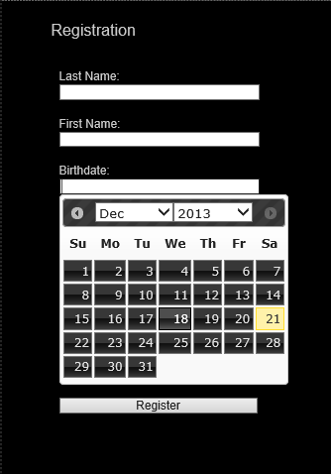

The password text field has a password strength feedback implemented, based on how many characters (lower and upper case), numbers, special characters etc. were used and in which combination they are arrayed:



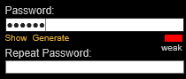

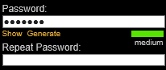





A password generator was included, producing good passwords (based on the password-strength check) for the user. The password created can be shows or hidden to prevent not knowing it:



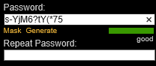

Repeating the password is mandatory to make sure the user has remembered the correct one.

## Search results page

When a user enters a search word into the search bar and presses ENTER or clicks on “GO!” he is redirected to a summarized search page, on which all movies that apply to the search words pattern are shown. The search looks for the title of the movie.

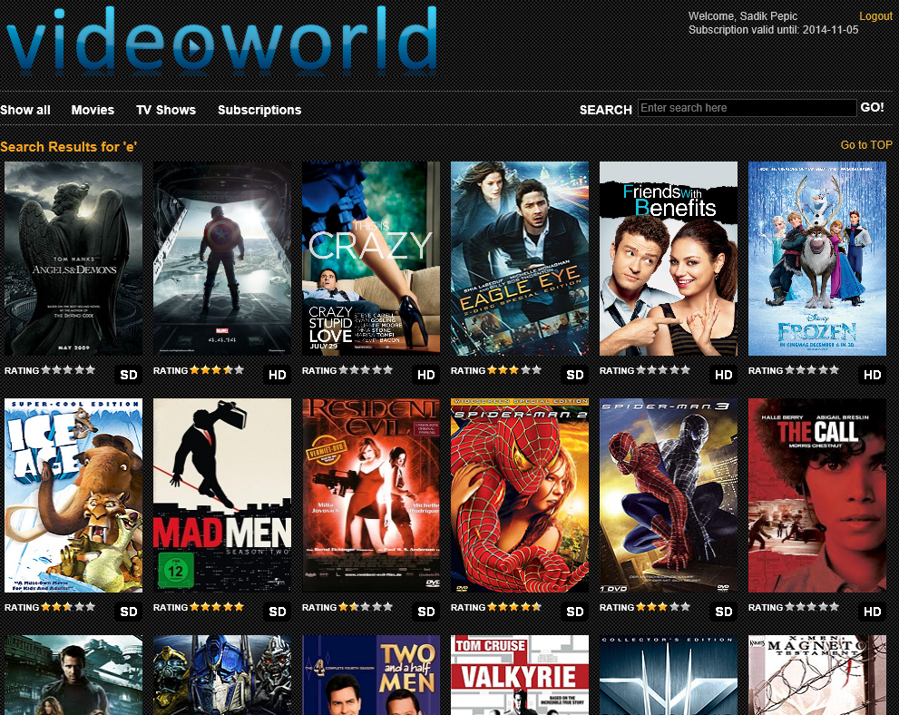

## Subscription page

Users who are already registered and logged in can buy subscription types based on their own needs (1 day, 1 week, 1 month, 1 year). Every type has a certain a price and an according discount (higher price 🡪 higher discount). Users can choose between two (at the moment) payment-types. All this content is created dynamically from the database, enabling easy addition of more subscription- and payment-types.



Because this VideoWorld now is intended as a scholar project, no actual payment type was implemented. Instead, a summary of what the redirection to an external payment site (e.g. PayPal, MasterCard etc.) would mean for the user is displayed (Modal, draggable dialogue with confirm button):

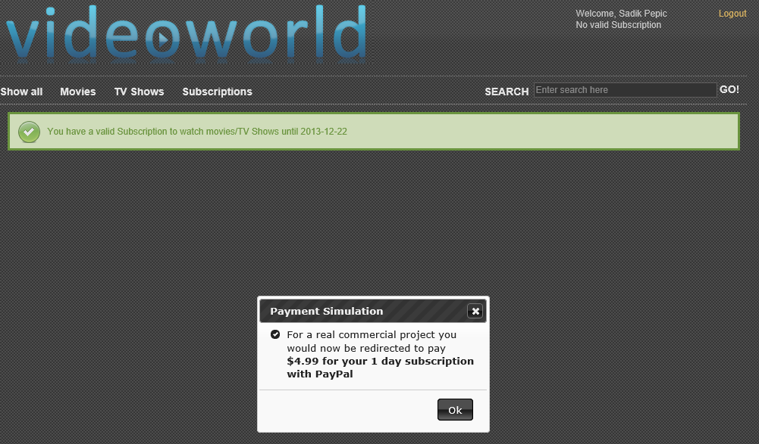

Confirming the newly bought subscription:





## Watching Video page

The central page for watching videos has implemented a player capable of displaying High Definition content and providing easy-to-use controls:





* Play (Press play on the play-sign or on the video itself)



* Pause (Press pause on the pause-sign or on the video itself)



* Loudness (Use adjuster to change volume or mute/unmute sound)
* Full-Screen-mode (Click on the expand to fullscreen button)



Fullscreen-mode can be closed again by clicking on the „minimize to normal“ button or pressing ESC.



* Elapsed-/Total time

The video page also provides the user with useful information about the movie / TV show. Depending on whether movies or TV shows are watched, different information is displayed to maximize use for the customer (This is based on the inheritance mechanism of the video entity 🡪 see ERM):

Movie TV show

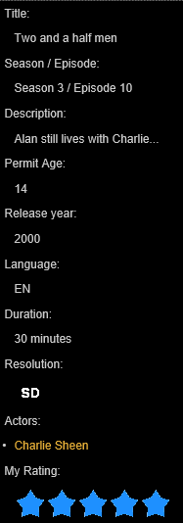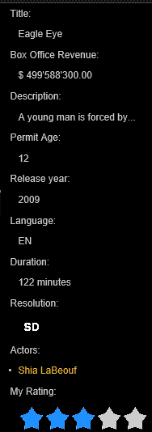

Box office revenue is displayed Season and episode is displayed

All actors of the movie are listed and can be clicked. This leads to the actors page (List of all his/her movies/TV shows)

Once the user has watched the movie/TV show he or she may rate it. This is done with a star system ranging from 0.5 to 5.0. Users are only allowed to rate the same video once. If nobody has rated the movie yet, 0 stars are displayed. If others have rated the movie, but not yet the user, on hovering on the stars that displayed the average of all other ratings, the user is enabled to rate himself.

**No ratings yet:**



**Rating the movie:**

Before rating



After rating

**Already rated the movie:**



**Others have rated but not the user:**



Before rating



While rating



After rating

## Actors page

All actors can be seen in the movies / TV shows the play on the video watching page:



When an actor is clicked, the user is forwarded to his/her summary, displaying all movies the actor acted in (and the year the movie was released):

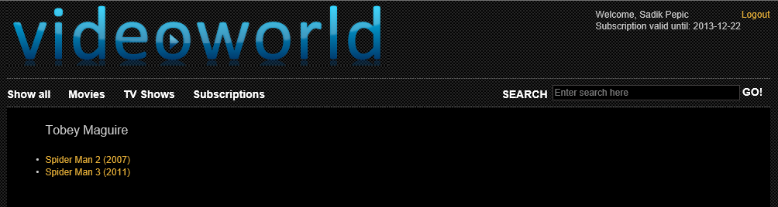

## Errors, messages and validations

VideoWorld distinguishes between errors, mere messages and success validation to give correct feedback about what did not or did go right.

Trying to watch a movie / TV show for an unregistered or not logged in user:



Trying to buy subscription not logged in:



Requesting a page that does not exist:

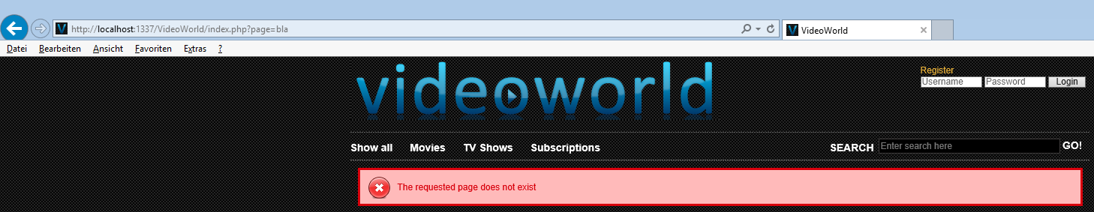

Trying to log in with a wrong username/password combination:



Trying to watch a movie / TV show without active subscription:



Valid subscription bought:



Trying to register with false format / missing information. Each error is shown separately:

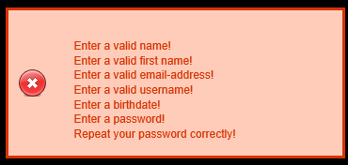

Registration completed:



Trying to watch content not suitable for the age of the user:



Trying to access content (movie / TV show) that does not exist (anymore):



## Screen size adaption / mobile usability

VideoWorld is implemented to be displayed differently based on the users’ resolution of the screen. All pages of VideoWorld are adapted to show content in different sizes. Especially the main / TV show / movie / search result pages are nicely adapted, thus enabling to view the sidebars in anyway:

High resolution (6 movies per row):

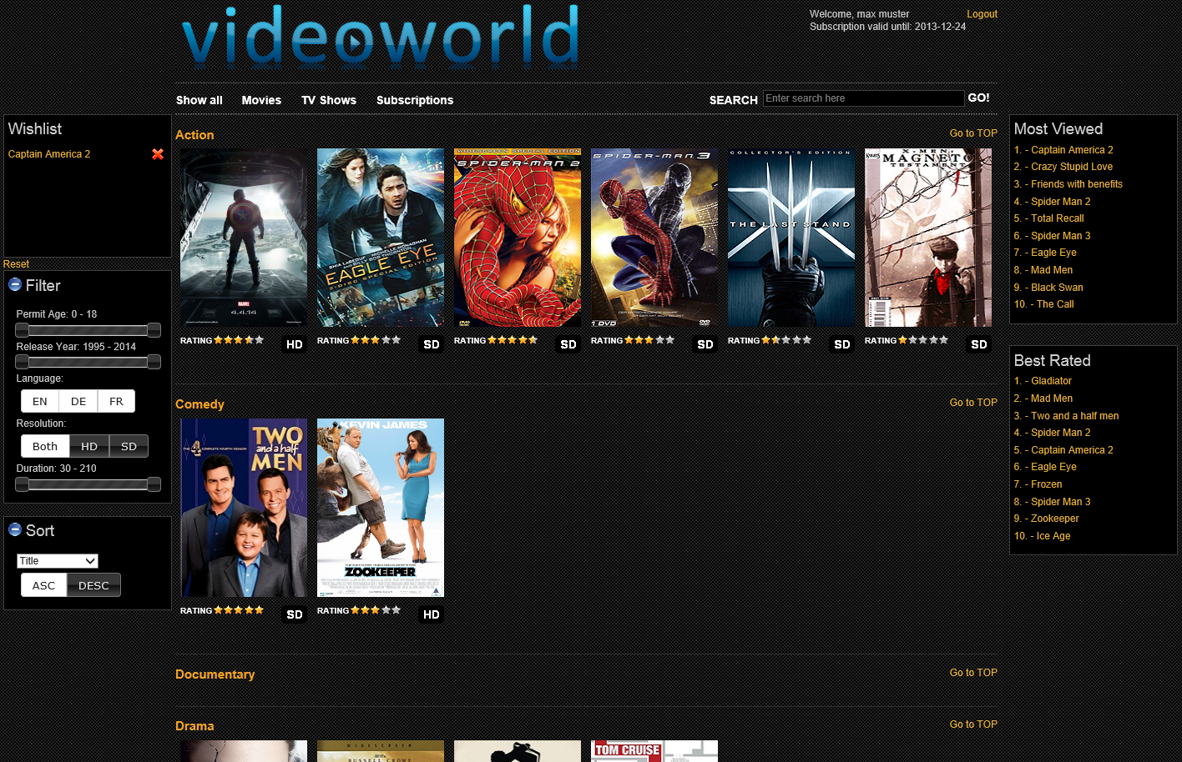

Medium resolution (5 movies per row):

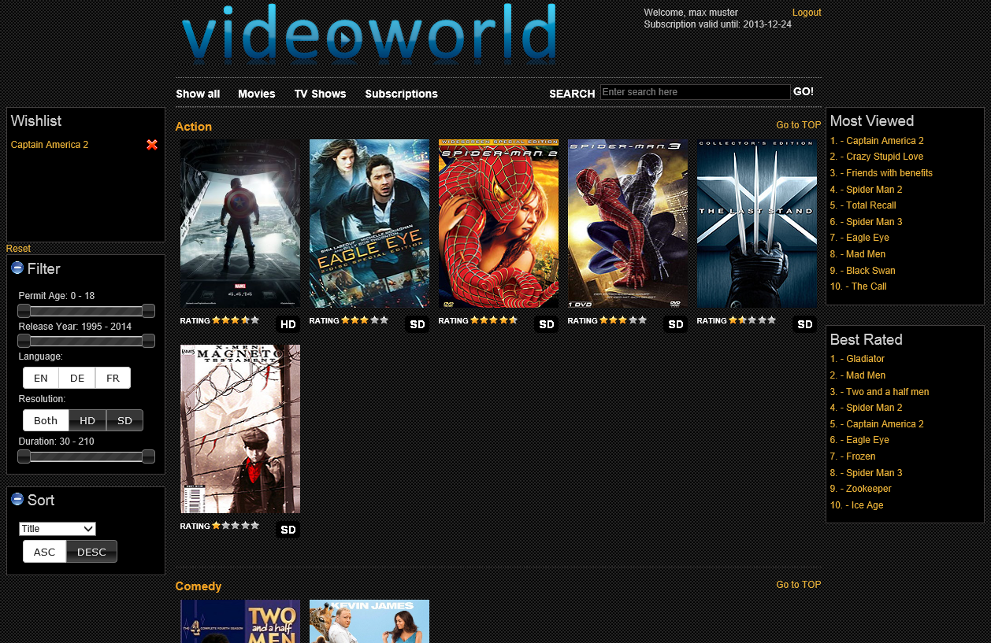

Low resolution (4 movies per row):

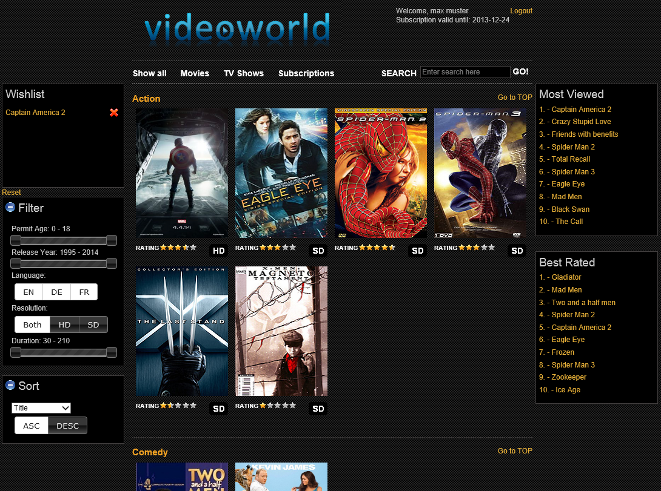

This feature allows users with low resolution devices such as mobile phones, older screens, tablets to view the content in the same manner as the ones with higher resolutions, because the width of the page significantly decreases.

All controls of VideoWorld, even the filter, sorting and searching functions are fully available on mobile devices (e.g. Apple iPhone) to enable high coverage of potential users.

# Technical requirements and guide for the installation

## Information

Due to the vast size of the project, only trailers were used as movies / TV shows. On the technical side nothing changes, but size could be significantly lowered. Additionally, not all Video posters and previews were included to minimize project size.

## Technical requirements

VideoWorld recommends a few technical minimum requirements that should be met to ensure best experience and performance:

|  |  |
| --- | --- |
| XAMPP | 1.8.2 or higher  🡪 PHP 5.4.16  🡪 Apache 2.4.4 |
| HTML 5 compatible Browser | Internet Explorer 11 or higher (recommended)  Mozilla Firefox 26 or higher  Safari 5.1.0 or higher  Google Chrome 31.0.1650.63 or higher |
| MySQL environment | MySQL Workbench 6.0 (recommended)  or  PHP my Admin db |

## Installation guide

There are only a few steps to get VideoWorld working in a local environment:

1. Install and setup XAMPP as your localhost (If you do not use the standard port, note down the chosen port now)
2. Setup the database by taking the VideoWorld\MySQL_Files\videoworld.sql file and executing it in your MySQL environment
3. Copy the entire the project into the folder that holds your internet projects in XAMPP (Default: htdocs)
4. Open db_connector.php and fill in the following information

$db_connection = new MySQL(true, "videoworld", "localhost", "**your Username in the DB**", "**your Password in the DB**");

or…

$db_connection = new MySQL(true, "videoworld", "localhost:yourPort", "**your Username in the DB**", "**your Password in the DB**");

1. Open mysql.php and fill in the following information

**private** $db_host = "localhost"; // server name (or: localhost:yourPort)

**private** $db_user = "root"; // your user name in the database envir.

**private** $db_pass = ""; // your password in the database envir.

1. Open http://localhost in your browser (or: use http://localhost:XXXX if you have defined a different port in step 1 for the XXXX).
2. Choose VideoWorld and let the show begin!

# Technical Implementation

## Architecture

This application was implemented in a 3-Tier client-server architecture. Additional, more specific layers can be added at any time in the future (e.g. isolated data access layer).

Presentation and Interaction

HTML, CSS, (JS, jQuery) Client

Business and Data Access Layer

PHP, jQuery/AJAX, JS, Client / Server

MySQL Connector

Persistence Layer

DBMS (MySQL) Server

## Entity Relationship Model (Database)

The following entity relationship model shows the entities, their attributes/data types and their relationship amongst each other.

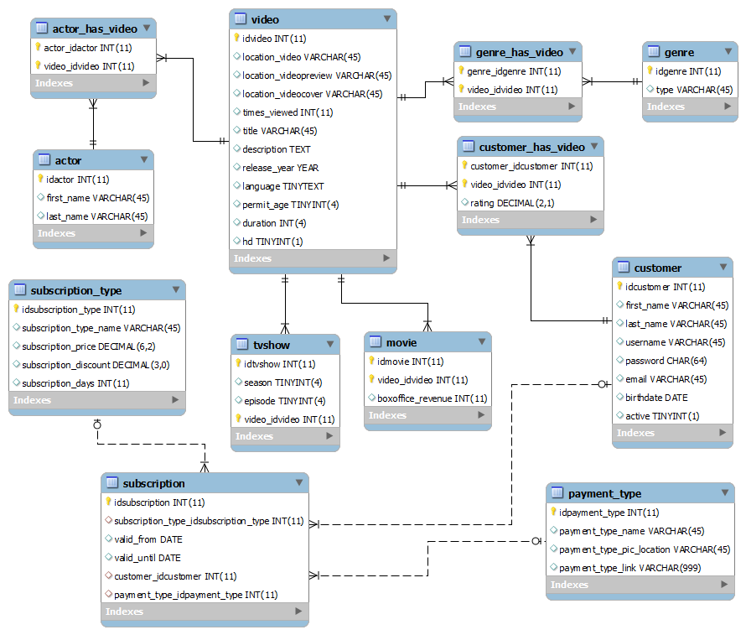

## Technologies used

The following is a coherent list of which technologies were used throughout the development of VideoWorld:

|  |  |  |
| --- | --- | --- |
| **Technology** | **Version** | **Remarks** |
| PHP | 5.4.16 |  |
| Eclipse | Kepler SR 1 | Development environment |
| XAMPP | 1.8.2 |  |
| HTML | HTML 5 |  |
| CSS | CSS 3 |  |
| Google SVN | - | Project internal versioning- & sharing-system, integrated into Eclipse |
| Ultimate MySQL Wrapper Class | 3.0 | PHP wrapper class |
| JavaScript | - |  |
| jQuery | 1.10.2.min | Javascript Framework |
| jQuery UI | 1.10.3.min | Javascript Framework |
| jQuery JSON | 2.4.min | Javascript Framework |
| jQuery lockfixed | .min | Javascript Framework |
| Prototype |  | Javascript Framework |
| Password widget | 1.0 | Javascript Framework |
| Scriptaculous | 1.9.0 | Javascript Framework |
| Starbox | 1.3 | Javascript Framework |
| Video.js | 4.3.0 | Javascript Framework |
| MySQL Connector | 1.2.4 | MySQL interfaces |
| MySQL Workbench | 6.0 | SQL development |
| Internet Explorer | 11 | Testing / Viewing purposes |
| Mozilla Firefox | 26 | Testing / Viewing purposes |
| Safari | 5.1.0 | Testing / Viewing purposes |
| Google Chrome | 31.0.1650.63 | Testing / Viewing purposes |
| Mp4-Videos | - | Standard High-Definition Videos |

# Meeting and exceeding requirements of Web Engineering Module

## Technological requirements

**Meeting requirements**

* Client-sided in-and output was implemented using HTML, CSS and several form elements
* Client-sided, dynamic manipulation of the content was realized using JavaScript (jQuery) in terms of direct HTML DOM tree manipulation.
* Server-sided, dynamic creation of content was implemented using PHP
* Server-sided, persistent Data was realized using a MySQL database with MySQL Connectors. Additionally on the client side, HTML 5 LocalStore was used to hold information persistently

**Exceeding requirements**

* State-of-the-art **media queries** (CSS3) were used to implement a device-/resolution-specific content for the user instead of a dedicated mobile version of the page (deprecated method where the browsers’ configuration is read and used to distinguish between the content to be produced).
* **jQuery** / **jQueryUI** was very often used to create nice-looking, easy-to-use and asynchronously called (**AJAX**) functionalities such as:
  + asynchronously called filtering functionality with sliders and AND/OR-choosers that trigger the content to be adapted to the users’ choice without reloading the entire page (jQuery / AJAX)
  + asynchronously called sorting functionality with dropdown for choice of attribute to be sorted and OR-chooser to set Ascending / Descending sorting that trigger the content to be adapted to the users’ choice without reloading the entire page (jQuery / AJAX)
  + asynchronously called searching function that adapts its content while the user types his search words (AutoComplete) into the text field without reloading the entire page (jQuery / AJAX)
  + asynchronously called login function that logs in / gives an error feedback without reloading the entire page (jQuery / AJAX)
* **HTML 5 LocalStore** was used to store the information about the movies a user wants to remember in the wishlist. AJAX calls are used to get the information about a specific movie dragged into the wishlist section without reloading the entire page (HTML 5 LocalStore / jQuery / AJAX)
* **HTML 5 Drag & Drop** mechanism was used in combination with jQuery to enable an easy-to-use control of the wishlist methodology
* **jQuery** was used to implement the modal dialogue for paying (draggable, modal)
* **jQuery** was used to implement the date-picker for registration enabling the user not to enter a false-format date in a nice-looking manner
* **jQuery** was used to implement hiding and showing the filter- and sorting-section
* **jQuery** was used to implement showing an on-hover, semi-transparent play image on the movies with the title
* **Starbox-Framework** in combination withthe **prototype-** and **scriptaculous-framework** were used to implement the rating-mechanism in an asynchronous, nice-looking way
* **HTML 5 video** was implemented using one of the best videoplayer-frameworks there currently is: **VideoJS** is an easy to implement, nice-looking, high-performance videoplayer capable of displaying HD-content in any browser
* **Password Widget-framework** was used to implement the password-strength-meter, password-generator and hiding/showing of the generated/self-written password
* **jQuery Lockfixed** was used to implement the fixed sidebars following the users’ scrolling
* **jQuery / JSON** was used to implement the local storage mechanism on which a conversion with JSON was very handy
* **Cascaded SQL queries (Queries within queries)** were used to ensure very dynamic creation of the overview section of the page (All / Movies / TV shows)
* **Ultimate MySQL Wrapper Class** **(PHP)** was used to ensure best possible connectivity/operations with the database. Especially Create / Read / Update / Delete (CRUD) operations are implemented very nicely in this easy-to-integrate wrapper. For future development such a wrapper saves a lot of time and budget concerning enhancements and new components requiring MySQL.

All mentioned technologies / frameworks were used in a complex manner and implemented in a nicely structured project. We are especially proud to present a filtering / sorting system, whose ranges for adjusters are based on database values and which, on change, asynchronously load the new content using AJAX.

## Content requirements

**Meeting requirements**

* VideoWorld’s data model consists of the minimum of two entities with a minimum of two attributes each
* VideoWorld’s data model contains of a minimum of one many-to-many (M:N) relation

**Exceeding requirements**

* VideoWorld has a complexly implemented very well normalized data model with 12 entities and…
  + Has a minimum of two attributes for each entity
  + Has a maximum of twelve attributes for each entity
  + Has three M:N relations
    - Video --- Actor 🡪 Actor has video
    - Video --- Genre 🡪 Genre has video
    - Video --- Customer 🡪 Customer has video
  + has a well-implemented referential integrity (Foreign Keys)
  + uses many crucial data types such as DATE, VARCHAR, DECIMAL, TINYINT, INT, CHAR, YEAR
  + Inheritance 🡪 Video is a conceptional generalization of TV shows and Movies.

Video provides mutual information for both movies and TV shows. Movies and TV shows each have specific information only suited for them. This inheritance is the fundament for the separation of both types through the entire application:

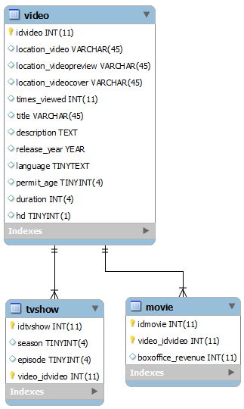

## Additional requirements

**Meeting requirements**

* VideoWorld is fully functional and was tested in several browsers (Google Chrome, Internet Explorer, Firefox, Safari)

**Exceeding requirements**

* Usability was optimized using easy-to-use controls and concepts such as
  + AutoComplete for search function
  + Preset Adjusters and buttons for filtering and sorting
  + A separation of movies / TV shows for the entire page (conceptional and technical)
  + Drag-and-Drop mechanism for the wishlist (Drag movies 🡪 drop in wishlist)
  + Easy-to-use and very well looking videoplayer
  + Easy-to-use and very well looking rating system with stars
  + Helpful feedbacks for the user (Validation, errors, success messages)
  + Screen-size-adaption for several different resolutions (mobile, desktop etc.)
* The design of VideoWorld was implemented in a very nice, elegant and sleek design using…
  + A very lucid structure of the page
  + Sidebars and sub-navigation (login / header) on most pages where they make sense
  + Nice effects and controls
  + Well-matched colors (grey, black, orange and blue mainly) and elements
  + Self-explaining controls that help the user navigate, filter, sort and search
  + Big eye-catching movie / TV show covers and previews (in the player)
  + Ratings and resolution information for each movie / TV show
* The structure of the project was intended to be very simple in order for future developers to find anything they look for right away 🡪 everything is where it belongs and structured nicely

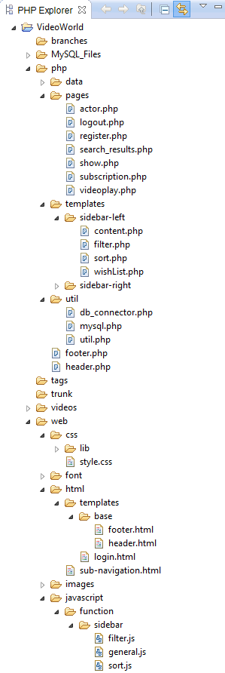

In VideoWorld the user should feel right at home with no explanation needed whatsoever. Although design is a subjective domain, we think VideoWorld was designed in a very good looking structure and layout and we are proud, although we are no web-designers, to have accomplished such a nice design.